


HILLDALE HOUSING ASSOCIATION
Tenant Satisfaction Measures – Summary of Approach 2025/26

Table of Contents

Introduction 3

Summary of Achieved Sample & Sample Method 3

Timing of Survey 4

Collection Method(s) 4

Sample Method 4

Representativeness 5

Questionnaire 9

Introduction

The Tenant Satisfaction Measures (TSM) Standard mandates that all registered providers develop and report TSMs in accordance with the guidelines set by the regulator. As part of this requirement, it is necessary for Hilldale Housing Association to inform its customers about its approach to conducting the TSM Perception survey and collecting data.
This document details Hilldale Housing Association methodology and outlines the criteria specified in the Regulator of Social Housing’s publication, Tenant Satisfaction Measures Return.
The Tenant Satisfaction Measures (TSM) Standard requires all registered providers to conduct tenant perception surveys and report performance annually as specified by the RSH. TSMs are intended to make landlords’ performance more visible to tenants so that tenants can hold their landlord to account. TSMs consist of 22 measures: 10 providing management information from data held by the landlord and 12 satisfaction measures gathered from tenant surveys. In addition to overall satisfaction with landlord services, the measures cover five key themes:
- Keeping properties in good repair
- Maintaining building safety
- Respectful and helpful engagement
- Responsible neighbourhood management
- Effective handling of complaints
Providers must publish a summary of the survey approach used to generate published tenant perception measures. This must be made clearly available alongside each set of tenant perception measures published by the provider.

Summary of Achieved Sample & Sample Method

Hilldale Housing Association works with Acuity Research & Practice Ltd, an accredited organisation that is dedicated to providing research services in the social housing sector. We use survey information to understand how our tenants feel about their homes and services and how we can improve. Acuity was commissioned for collecting, generating and validating reported perception measures.
In 2025/26, Hilldale Housing Association completed TSM surveys with a census of all residents. The sample size was chosen to ensure that the level of statistical accuracy set out by the Regulator of Social Housing was met. Hilldale Housing Association must ensure that they survey enough residents to meet a statistical accuracy (margin of error at 95% confidence interval) of +/- 5%.
During 2025/26, Hilldale Housing Association completed 170 TSM surveys. Hilldale Housing Association have 836 properties which means that a statistical accuracy level of +/- ±6.7% was achieved.
No tenant was removed from the sample frame.
There are no incentives used for this survey.

Timing of Survey
Hilldale Housing Association carried out a total of 170 surveys between 16/12/2025 and 31/3/2026.


Collection Method(s)

The TSM Surveys were completed via Online and Postal methodologies. The rationale for using a mixed methodology approach is:

- Accessibility and Inclusivity: Ensuring accessibility for all tenants, which aligns with our goal of reaching a broad and representative sample
- Response Rates: Using a mixed methodology approach maximises the robustness of our data and ensuring the results truly reflect the tenant base. Including a telephone aspect also allows Hilldale Housing Association to be reactive to flags and alerts, which improves customer recovery
- Reliability and Consistency: Maintaining consistency with previous years’ methodologies allows for more reliable trend analysis. It also enables richer information to be gathered.
- Independence: Using Acuity, an independent market research agency, means that participants are free from influence from the rest of the organisation.

Sample Method

Survey responses are immediately shared with Hilldale Housing Association, who then manage a follow up and review process which includes both responding to feedback as necessary, and analysing the feedback, to understand how we can improve.

Representativeness

The final survey data was weighted on Age Group to ensure that the survey was representative of the tenant population as a whole. The characteristics by which representativeness was determined were:

Age Group | Population | Sample
25–34 | 25% | 26%
35–44 | 24% | 23%
45–54 | 18% | 24%
55–64 | 13% | 16%
65–74 | 5% | 4%
75+ | 1% | 1%
Unknown | 14% | 6%

Gender | Population | Sample
Female | 33% | 33%
Male | 67% | 67%

Area | Population | Sample
East Midlands | 9% | 11%
East Of England | 2% | 2%
London | 1% | 3%
North East | 0.60% | 0%
North West | 49% | 49%
South East | 6% | 5%
South West | 8% | 8%
West Midlands | 3% | 2%
Yorkshire And The Humber | 21% | 19%

Patch | Population | Sample
Ashleigh Herving | 5% | 6%
Deana Taylor | 14% | 15%
Elaine Downes | 9% | 11%
Kevin Tushingham | 12% | 13%
Meg English | 12% | 14%
Nicola Molyneux | 10% | 11%
Quays | 16% | 11%
Sam Downes | 16% | 10%
Sherrine Johnson | 8% | 9%

Ethnicity | Population | Sample
Asian / Asian British:Any Other Asian Background | 0.12% | 0.59%
Asian / Asian British:Bangladeshi | 0.24% | 0%
Asian / Asian British:Chinese | 0.12% | 0.59%
Asian / Asian British:Indian | 0.24% | 0%
Asian / Asian British:Pakistani | 0.96% | 1%
Asian/Asian British:Other | 0.24% | 0%
Asian/Asian British:Pakistani | 0.12% | 0%
Black / African / Caribbean / Black British:African | 0.48% | 0%
Black / African / Caribbean / Black British:Any Other Black / African / Caribbean Background | 0.12% | 0.59%
Black / African / Caribbean / Black British:Caribbean | 0.36% | 0%
Black/Black British:African | 0.12% | 0%
Black/Black British:Carribean | 0.24% | 1%
Black/Black British:Other | 0.12% | 0%
Mixed / Multiple Ethnic Groups:Any Other Mixed / Multiple Ethnic Background | 0.12% | 0%
Mixed / Multiple Ethnic Groups:White And Asian | 0.24% | 0%
Mixed / Multiple Ethnic Groups:White And Black Caribbean | 0.24% | 0%
Mixed: Other | 0.12% | 0%
Refused | 2% | 2%
White: British | 38% | 37%
White: Other | 0.36% | 0.59%
White:Any Other White Background | 0.72% | 2%
White:English / Welsh / Scottish / Northern Irish / British | 55% | 55%

Religion | Population | Sample
Catholic | 0.24% | 0.59%
Christian (All) | 3% | 3%
Muslim | 0.84% | 0%
Sikh | 0.12% | 0%
Unknown | 96% | 96%

Length of Tenancy | Population | Sample
1 - 3 Years | 35% | 35%
11 - 20 Years | 2% | 1%
4 - 5 Years | 16% | 13%
6 - 10 Years | 21% | 29%
< 1 Year | 26% | 22%

Property Type | Population | Sample
House Of Multiple Occupation (Shared) Bungalow | 3% | 3%
House Of Multiple Occupation (Shared) Flat | 2% | 1%
House Of Multiple Occupation (Shared) House | 21% | 24%
Self-Contained Bungalow | 4% | 6%
Self-Contained Flat | 65% | 59%
Self-Contained House | 5% | 7%

Questionnaire & Introductory Text
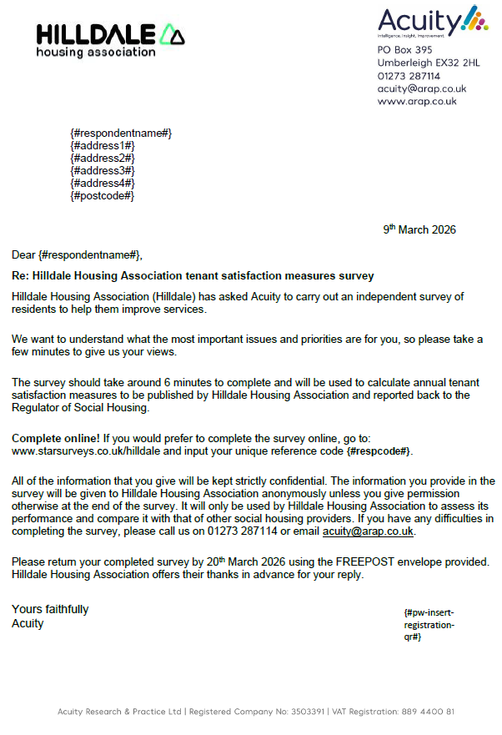

Intro for Postal Survey

Intro for Online Survey
Hello is that [Respondent Name],
My name is [Interviewer Name] and I'm calling on behalf of [Organisation Name] from an independent research agency called Acuity. We are carrying out short satisfaction surveys with [description] to find out how satisfied you are with your home and the services you receive from them. Would you be able to spare [Survey Length] minutes to go through the survey with me now?
IF NO ASK: can I call back at another time?
No appointments after [Project End Date]
IVR READ OUT: The survey will be used to calculate tenant satisfaction measures to be published by [Organisation Name] and reported back to the Regulator of Social Housing.
If the customer would like to verify the validity of this survey they need to contact [Organisation Name] by email [Email Address] or by phone [Telephone Number].
NB: Data sharing if challenged –
“Your landlord will, from time to time, share your personal data with third parties for legitimate interests. This could be transferring it to repairs contractors to carry out repairs or for research purposes such as this, to ensure they are giving the best service possible. When signing your application form or agreement, you are automatically included in this legitimate interest clause which can also be found in the data privacy statement on your landlord’s website.
You can however opt out of this by contacting your landlord. If you are not happy that your landlord has passed your details to us and would rather we did not contact you again, we can remove your details from our system and flag this back to your landlord. I however urge you to contact them to request your details are not shared with other parties.”
Before we start, I need to make you aware that we are bound by the Market Research Society Code of Conduct. All calls will be recorded for training and quality purposes. Any information that you give us will be treated in confidence and will be used to find ways of improving the service that [Organisation Name] provides. [Organisation Name] will be able to identify you from your survey responses, are you happy to continue?
NB: If asked – call recordings are stored for 90 days to allow our company to verify and validate the quality of interviews.
- Yes
- No

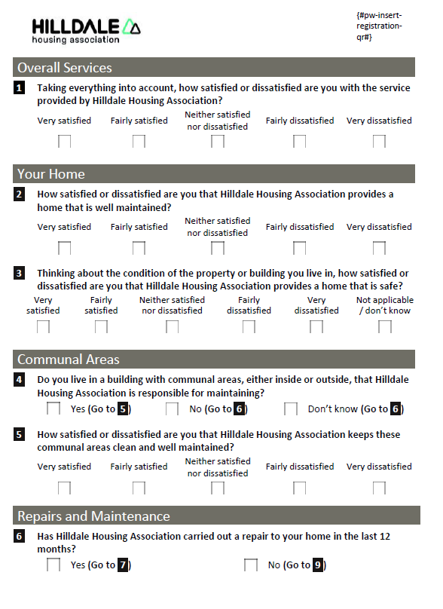
Question set for LCRA

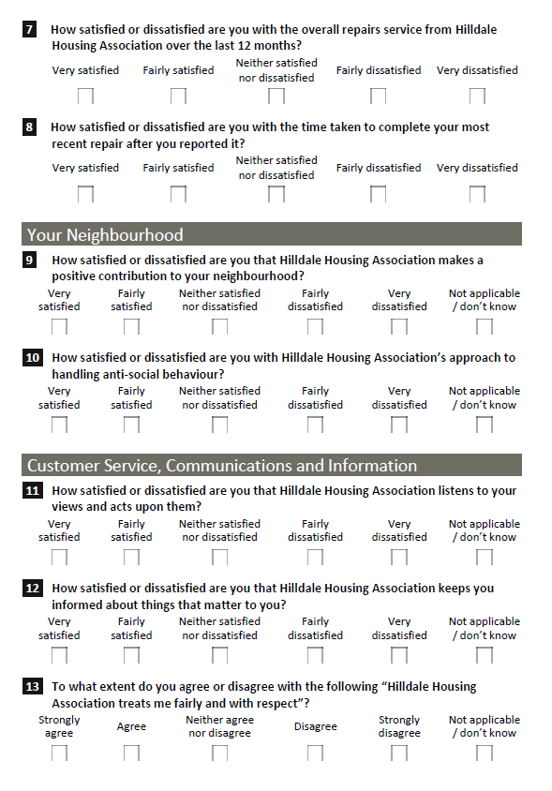

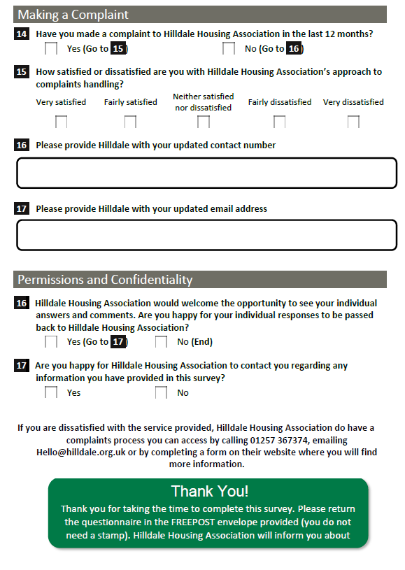

Report by Acuity Research & Practice

01273 287114
acuity@arap.co.uk

Results:
All results are calculated and provided in a document by Acuity, the results for comparison are below in addition to the report
TSM | 2024/25 TSM Results  Percentage satisfied | 2025/26 TSM Results  Percentage satisfied | Responded  (2025/26) | Variance
TP01  Satisfied are you with the service provided by your landlord? | 89% | 74%  (123 satisfied) | 167 | -16%
TP02 how satisfied or dissatisfied are you with the overall repairs service from your landlord over the last 12 months | 82% | 75%  (96 satisfied) | 126 | -8%
TP03 satisfied are you with the time taken to complete your most recent repair after you reported it? | 80% | 68%  (85 satisfied) | 123 | -12%
TP04 How satisfied or dissatisfied are you that your landlord provides a home that is well maintained? | 87% | 74%  (119 satisfied) | 161 | -13%
TP05 Thinking about the condition of the property or building you live in, how satisfied or dissatisfied are you that your landlord provides a home that is safe | 89% | 76%  (125 satisfied) | 168 | -13%
TP06 How satisfied or dissatisfied are you that your landlord listens to your views and acts upon them? | 84% | 67%  (92 satisfied) | 155 | -17%
TP07 How satisfied or dissatisfied are you with the way your landlord keeps you informed about things that matter to you? | 81% | 68%  (97 satisfied) | 155 | -12%
TP08 To what extent do you agree or disagree with the following statement? My landlord treats me fairly and with respect. | 90% | 79%  (115 satisfied) | 156 | -11%
TP09 how satisfied or dissatisfied are you with your landlords approach to complaints handling? | 66% | 64%  (35 satisfied) | 52 | -2%
TP10 how satisfied or dissatisfied are you that your landlord keeps these communal areas clean and well-maintained? | 79% | 70.4%  (88 satisfied) | 123 | -8%
TP11 How satisfied or dissatisfied are you that your landlord makes a positive contribution to your neighbourhood? | 65% | 59%  (77 satisfied) | 158 | -6%
TP12 How satisfied or dissatisfied are you with your landlords approach to handling anti-social behaviour? | 80% | 61%  (71 satisfied) | 157 | -18%

Management information data results:
In addition to the Tenant Perception Measures collected through the tenant survey and independently administered by Acuity, the Regulator of Social Housing requires landlords to report a series of Management Information Measures as part of the Tenant Satisfaction Measures (TSM) framework.
These measures are derived from organisational performance data rather than tenant survey responses and provide an objective assessment of service delivery. The measures cover four key areas: building safety, repairs, complaints handling and neighbourhood management. Together with the perception measures, they provide a comprehensive view of landlord performance and help ensure transparency and accountability to tenants and the Regulator of Social Housing. These are:
CH01 | Complaints relative to the size of the landlord, 1.stage 1 complaints and 2. Stage 2 complaints received per 1,000 homes
CH02 | Complaints responded to within Complaint Handling Code timescales
NM01 | Anti-social behaviour cases relative to the size of the landlord  1. anti-social behaviour cases, of which  2. anti-social behaviour cases that involve hate incidents  opened per 1,000 homes.
RP01 | Homes that do not meet the Decent Homes Standard
RP02 | Repairs completed within target timescale
BS01 | Gas safety checks
BS02 | Fire safety checks
BS03 | Asbestos safety checks
BS04 | Water safety checks
BS05 | Lift safety checks  The results below present our performance against the required Management Information Measures for the reporting period.

TSM | 2024/2025 TSM Results | 2025/26 TSM Results | Variance
CH01 (Complaints relative to the size of the landlord, 1.stage 1 complaints and 2. Stage 2 complaints received per 1,000 homes) | Stage 1 – 33.8  Stage 2 – 1.9 | Stage 1 – 25.3  Stage 2 – 6.3 | -8.5  +4.4
CH02 (Complaints responded to within Complaint Handling Code timescales) | Stage 1 – 86.1  Stage 2 – 100% | Stage 1 – 89.3%  Stage 2 – 85.7% | +3.2%  -14.3%
NM01 (Anti-social behaviour cases relative to the size of the landlord  1. anti-social behaviour cases, of which  2. anti-social behaviour cases that involve hate incidents  opened per 1,000 homes.) | ASB – 93  Hate Crime – 0.90 | ASB-99.5  Hate Crime- 0.9 | +1.5  0
RP01 (Homes that do not meet the Decent Homes Standard) | 0% | 0.3% | -0.3%
RP02 (Repairs completed within target timescale ) | Non-emergency – 99.2%  Emergency – 99.6% | Non-emergency – 94.5%  Emergency – 98.3% | -0.3%  -2.3%
BS01 Gas safety checks | 100% | 100% | 0%
BS02 Fire safety checks | 100% | 99% | -1%
BS03 Asbestos safety checks | 100% | 100% | 0%
BS04 Water safety checks | 100% | 100% | 0%
BS05 Lift safety checks | 100% | 100% | 0%

